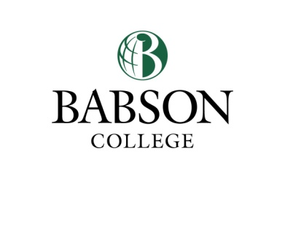
Office of Corporate, Foundation & Government Relations
Alumni Hall 209 (silverman@babson.edu; ext. 5993)

Assistance Form

The Office of Corporate, Foundation and Government Relations (CFGR) provides assistance to faculty members who are seeking funding from external sources for research projects. Please provide the information requested below to begin the process. You must have this form signed by your Division Chair to ensure he or she is aware of the research you are undertaking and the contributions you are making to Babson College.

Name of Investigator(s)

Date__________________

Division

Phone Number__________________

Project/Proposal Title

Amount of money you wish the Office of Corporate, Foundation & Government Relations to assist in securing:

List any prospects you are aware of that may have an interest in supporting this project:

Division Chair’s Signature Date

Should you ultimately request funding from an external agency, be aware
that your final proposal must be submitted to the CFGR
at least five working days before the deadline.

In the space below, please provide a brief summary of your project in lay terms. Be sure to address the time frame for the project, its current status, and the significance of the project to Babson College and to your field in general. Please describe what benefit this project will provide to the community and/or to the greater society. Include any general comments you feel may be important.

If necessary, continue project summary on separate page.

Also, on a separate sheet of paper, please provide a one-page budget summary for the project. This summary should specify that portion of the project for which external funds are sought. Be sure to provide specific information in each category, such as type of personnel and equipment. The following example may be used as a guide in the preparation of your budget. A budget template can also be found online at K:/Faculty/Sponsored Programs/Forms/ Grant Proposal Budget.xls.

SAMPLE BUDGET

YEAR ONE YEAR TWO
PERSONNEL SALARIES
& BENEFITS

EQUIPMENT

SUPPLIES

TRAVEL AND RELATED

TOTAL PROJECT COSTS

OVERHEAD COSTS (Babson’s federally negotiated rate is 60.1% of salaries and wages; however some agencies have limits on what they will allow. 15% unless the grantor specifies lower cap.)

= TOTAL FUNDING REQUESTED

